- MAXSUM
运行结果：
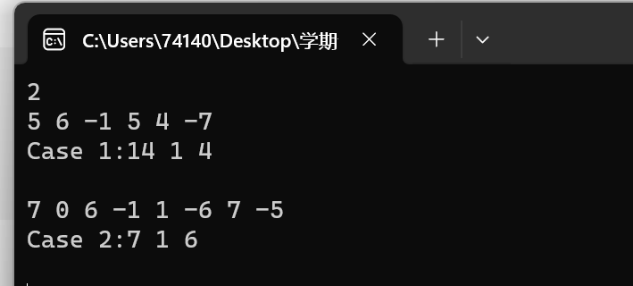
程序代码：
#include <iostream>
#include <vector>
#include <tuple> // Add this line
using namespace std;

tuple<int, int, int> max_subsequence_sum(const vector<int>& nums) {
int max_sum = INT_MIN;
int current_sum = 0;
int start_position = 1;
int end_position = 1;
int current_start = 1;

for (int i = 0; i < nums.size(); ++i) {
current_sum += nums[i];

if (current_sum > max_sum) {
max_sum = current_sum;
start_position = current_start;
end_position = i + 1;
}

if (current_sum < 0) {
current_sum = 0;
current_start = i + 2;
}
}

return make_tuple(max_sum, start_position, end_position);
}

int main() {
int t;
cin >> t;

for (int case_num = 1; case_num <= t+1; ++case_num) {
int n;
cin >> n;
vector<int> sequence(n);
for (int i = 0; i < n; ++i) {
cin >> sequence[i];
}

auto result = max_subsequence_sum(sequence);
int max_sum, start_position, end_position;
tie(max_sum, start_position, end_position) = result;

cout << "Case " << case_num << ":" << max_sum << " " << start_position << " " << end_position << endl;

if (case_num <= t+1) {
cout << endl; // Output a blank line between two cases
}
}
getchar();
return 0;
}

2. Robberies

运行结果：
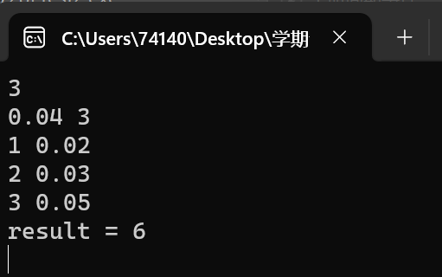
程序代码：#include <iostream>
#include <vector>
#include <algorithm>

using namespace std;

struct Bank {
int money;
double probability;
};

bool compareBanks(const Bank& a, const Bank& b) {
return a.probability < b.probability;
}

int maxMoney(vector<Bank>& banks, double limit) {
sort(banks.begin(), banks.end(), compareBanks);

int totalMoney = 0;
double currentProbability = 1.0;

for (const Bank& bank : banks) {
currentProbability *= (1.0 - bank.probability);

if (currentProbability >= limit) {
totalMoney += bank.money;
}
else {
break; // Stop when the probability goes below the limit
}
}

return totalMoney;
}

int main() {
int T;
cin >> T;

while (T--) {
double limit;
int N;
cin >> limit >> N;

vector<Bank> banks(N);

for (int i = 0; i < N; i++) {
cin >> banks[i].money >> banks[i].probability;
}

int result = maxMoney(banks, limit);
cout << "result = " << result << endl;
}

return 0;
}

3.Employment Planning
运行结果：
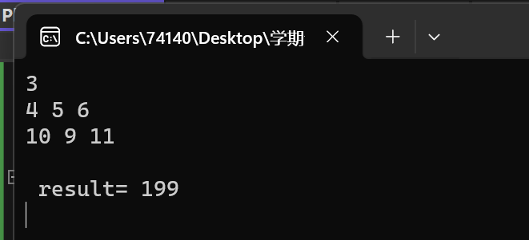
程序代码：
#include <stdio.h>
#include <string.h>
#include <algorithm>
#include <math.h>
#include <iostream>
#define inf 0x3f3f3f
using namespace std;
int n, x, y, z;
int a[20];
int dp[15][2000];
int main()
{
while (~scanf_s("%d", &n), n)
{
int maxx = -1;
memset(a, 0, sizeof(a));
scanf_s("%d%d%d", &x, &y, &z);
for (int i = 1; i <= n; i++)
{
scanf_s("%d", &a[i]);
maxx = max(maxx, a[i]);
}
memset(dp, inf, sizeof(dp));
for (int i = a[1]; i <= maxx; i++)
dp[1][i] = x * i + y * i;
for (int i = 2; i <= n; i++)
for (int j = a[i]; j <= maxx; j++)
for (int k = 0; k <= maxx; k++)
{
if (k <= j)
dp[i][j] = min(dp[i][j], dp[i - 1][k] + (j - k) * x + j * y);
else
dp[i][j] = min(dp[i][j], dp[i - 1][k] + (k - j) * z + j * y);
}
int num = inf;
for (int j = 0; j <= maxx; j++)
num = min(num, dp[n][j]);
printf("\n result= %d\n", num);
}
return 0;
}

4.Attack on Titans
运行结果：
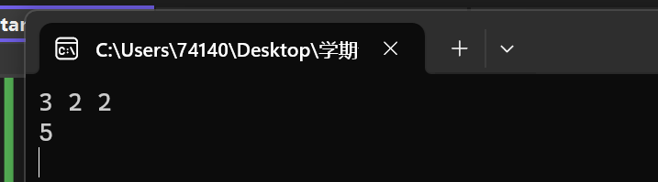
程序代码：
#include <iostream>
using namespace std;

const int MOD = 1000000007;

long long power(long long base, long long exponent) {
long long result = 1;
while (exponent > 0) {
if (exponent % 2 == 1) {
result = (result * base) % MOD;
}
base = (base * base) % MOD;
exponent /= 2;
}
return result;
}

long long countWays(int N, int M, int K) {
long long result = 0;

// Calculate ways for Garrison members
result += power(M + 1, N - K);

// Subtract ways for Recon Corp members
for (int i = 1; i <= K; i++) {
result = (result - power(i + 1, N - i) + MOD) % MOD;
}

return MOD-result+1;
}

int main() {

int T = 2;

while (T--) {
int N, M, K;
cin >> N >> M >> K;

long long ways = countWays(N, M, K);
cout << ways << endl;
}

return 0;
}

5．Advanced Fruits
运行结果：
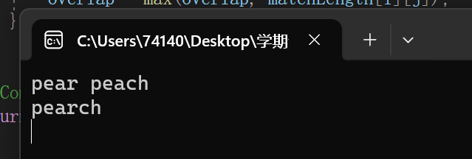、
程序代码：
#include <iostream>
#include <string>
#include <vector>
using namespace std;

string shortestName(const string& fruit1, const string& fruit2) {
int len1 = fruit1.length();
int len2 = fruit2.length();

// Create a table to store the lengths of matching suffixes
vector<vector<int>> matchLength(len1 + 1, vector<int>(len2 + 1, 0));

// Fill in the table with the lengths of matching suffixes
for (int i = len1 - 1; i >= 0; i--) {
for (int j = len2 - 1; j >= 0; j--) {
if (fruit1[i] == fruit2[j]) {
matchLength[i][j] = matchLength[i + 1][j + 1] + 1;
}
}
}

// Find the maximum overlap between the two fruit names
int overlap = 0;
for (int i = 0; i < len1; i++) {
for (int j = 0; j < len2; j++) {
overlap = max(overlap, matchLength[i][j]);
}
}

// Combine the fruit names, excluding the overlapping part
return fruit1 + fruit2.substr(overlap);
}

int main() {
string fruit1, fruit2;

while (cin >> fruit1 >> fruit2) {
string result = shortestName(fruit1, fruit2);
cout << result << endl;
}

return 0;
}

